Lab - Install and Setup Terraform
Before you can start working with Terraform (an Infrastructure-as-Code tool), you’ll need a few essentials set up on your machine:
- Terraform itself
- A code editor like Visual Studio Code (VS Code)
- The Terraform extension for VS Code
- The Azure CLI to interact with Azure resources
In this lab, we’ll walk through a step-by-step guide to install and configure these tools so you can seamlessly use Terraform with Azure Cloud.

Pre-requisite
1. Code editor tool, Visual Studio code
2. A user account on Azure Cloud with active subscription

Learning Objectives:
By the end of this lab, you will be able to:
- Download and install Terraform – set up the core Infrastructure-as-Code tool on your system.
- Install the Azure CLI – configure the command-line interface to interact with Azure resources.
- Add the Terraform extension to Visual Studio Code – enhance your coding experience with syntax highlighting, IntelliSense, and easy deployment integration.

Step by step guide

Download and install Terraform
Terraform is an open-source tool and supports all operating systems.
Download the terraform executable from the following link --
https://www.terraform.io/downloads

On the Mac operating system
You can run the following commands using Brew.
brew tap hashicorp/tap
brew install hashicorp/tap/terraform
In case you don’t have brew installed on the Mac operating system.
Run the following command –
/bin/bash -c "$(curl -fsSL https://raw.githubusercontent.com/Homebrew/install/HEAD/install.sh)"
For more information on brew, follow this link – https://brew.sh/

On Windows operating system –
First, download the terraform executable from the below page --
https://www.terraform.io/downloads (Windows tab)
After downloading the terraform, add the executable path to the environment variables.
Refer to this link to set the environment variable

For Linux, you can follow the following commands
Ensure that your system is up to date and you have installed the gnupg, software-properties-common, and curl packages installed. You will use these packages to verify HashiCorp's GPG signature and install HashiCorp's Debian package repository.
sudo apt-get update && sudo apt-get install -y gnupg software-properties-common
Install the HashiCorp GPG key.
wget -O- https://apt.releases.hashicorp.com/gpg | \
gpg --dearmor | \
sudo tee /usr/share/keyrings/hashicorp-archive-keyring.gpg > /dev/null
Verify the key’s print:
gpg --no-default-keyring \
--keyring /usr/share/keyrings/hashicorp-archive-keyring.gpg \
--fingerprint

The gpg command will report the key fingerprint:
/usr/share/keyrings/hashicorp-archive-keyring.gpg
-------------------------------------------------
pub rsa4096 XXXX-XX-XX [SC]
AAAA AAAA AAAA AAAA
uid [ unknown] HashiCorp Security (HashiCorp Package Signing) <security+packaging@hashicorp.com>
sub rsa4096 XXXX-XX-XX [E]

Add the official HashiCorp repository to your system. The lsb_release -cs command finds the distribution release codename for your current system, such as buster, groovy, or sid.
$ echo "deb [signed-by=/usr/share/keyrings/hashicorp-archive-keyring.gpg] \
https://apt.releases.hashicorp.com $(lsb_release -cs) main" | \
sudo tee /etc/apt/sources.list.d/hashicorp.list
Download the package information from HashiCorp.
$ sudo apt update
Install Terraform from the new repository.
$ sudo apt-get install terraform

Download and Install Azure CLI

On Mac Operating System -
Homebrew is the easiest way to manage your CLI install. It provides convenient ways to install, update, and uninstall. If you don't have homebrew available on your system, install homebrew before continuing.
You can install the Azure CLI on macOS by updating your brew repository information, and then running the install command:

brew update && brew install azure-cli

On a Linux Machine -
Option 1 -
The easiest way to install the Azure CLI is through a script maintained by the Azure CLI team. This script runs all installation commands in one step. This script is downloaded via curl and piped directly to bash to install the CLI.
curl -sL https://aka.ms/InstallAzureCLIDeb | sudo bash

Option 2 -
If you prefer a step-by-step installation process, complete the following steps to install the Azure CLI.
1. Get packages needed for the installation process:
sudo apt-get update
sudo apt-get install apt-transport-https ca-certificates curl gnupg lsb-release

2. Download and install the Microsoft signing key:

sudo mkdir -p /etc/apt/keyrings
curl -sLS https://packages.microsoft.com/keys/microsoft.asc |
gpg --dearmor | sudo tee /etc/apt/keyrings/microsoft.gpg > /dev/null
sudo chmod go+r /etc/apt/keyrings/microsoft.gpg

3. Add the Azure CLI software repository:

AZ_DIST=$(lsb_release -cs)
echo "Types: deb
URIs: https://packages.microsoft.com/repos/azure-cli/
Suites: ${AZ_DIST}
Components: main
Architectures: $(dpkg --print-architecture)
Signed-by: /etc/apt/keyrings/microsoft.gpg" | sudo tee /etc/apt/sources.list.d/azure-cli.sources

4. Update repository information and install the azure-cli package:

sudo apt-get update
sudo apt-get install azure-cli

On a Windows Machine -

The Azure Command-Line Interface (CLI) is a cross-platform command-line tool that can be installed locally on Windows computers. You can use the Azure CLI for Windows to connect to Azure and execute administrative commands on Azure resources. The Azure CLI for Windows can also be used from a browser through the Azure Cloud Shell or run from inside a Docker container.
For Windows, the Azure CLI is installed via an MSI or a ZIP package, which gives you access to the CLI through the Windows Command Prompt (CMD) or PowerShell.
Download and install the latest release of the Azure CLI. When the installer asks if it can make changes to your computer, select the "Yes" box.
Latest MSI of the Azure CLI (32-bit)
Latest MSI of the Azure CLI (64-bit)
If you have previously installed the Azure CLI, running either the 32-bit or 64-bit MSI will overwrite an existing installation.

Install Visual Studio Code Extension for Terraform
- Navigate to the extension tab as highlighted in the screenshot below.

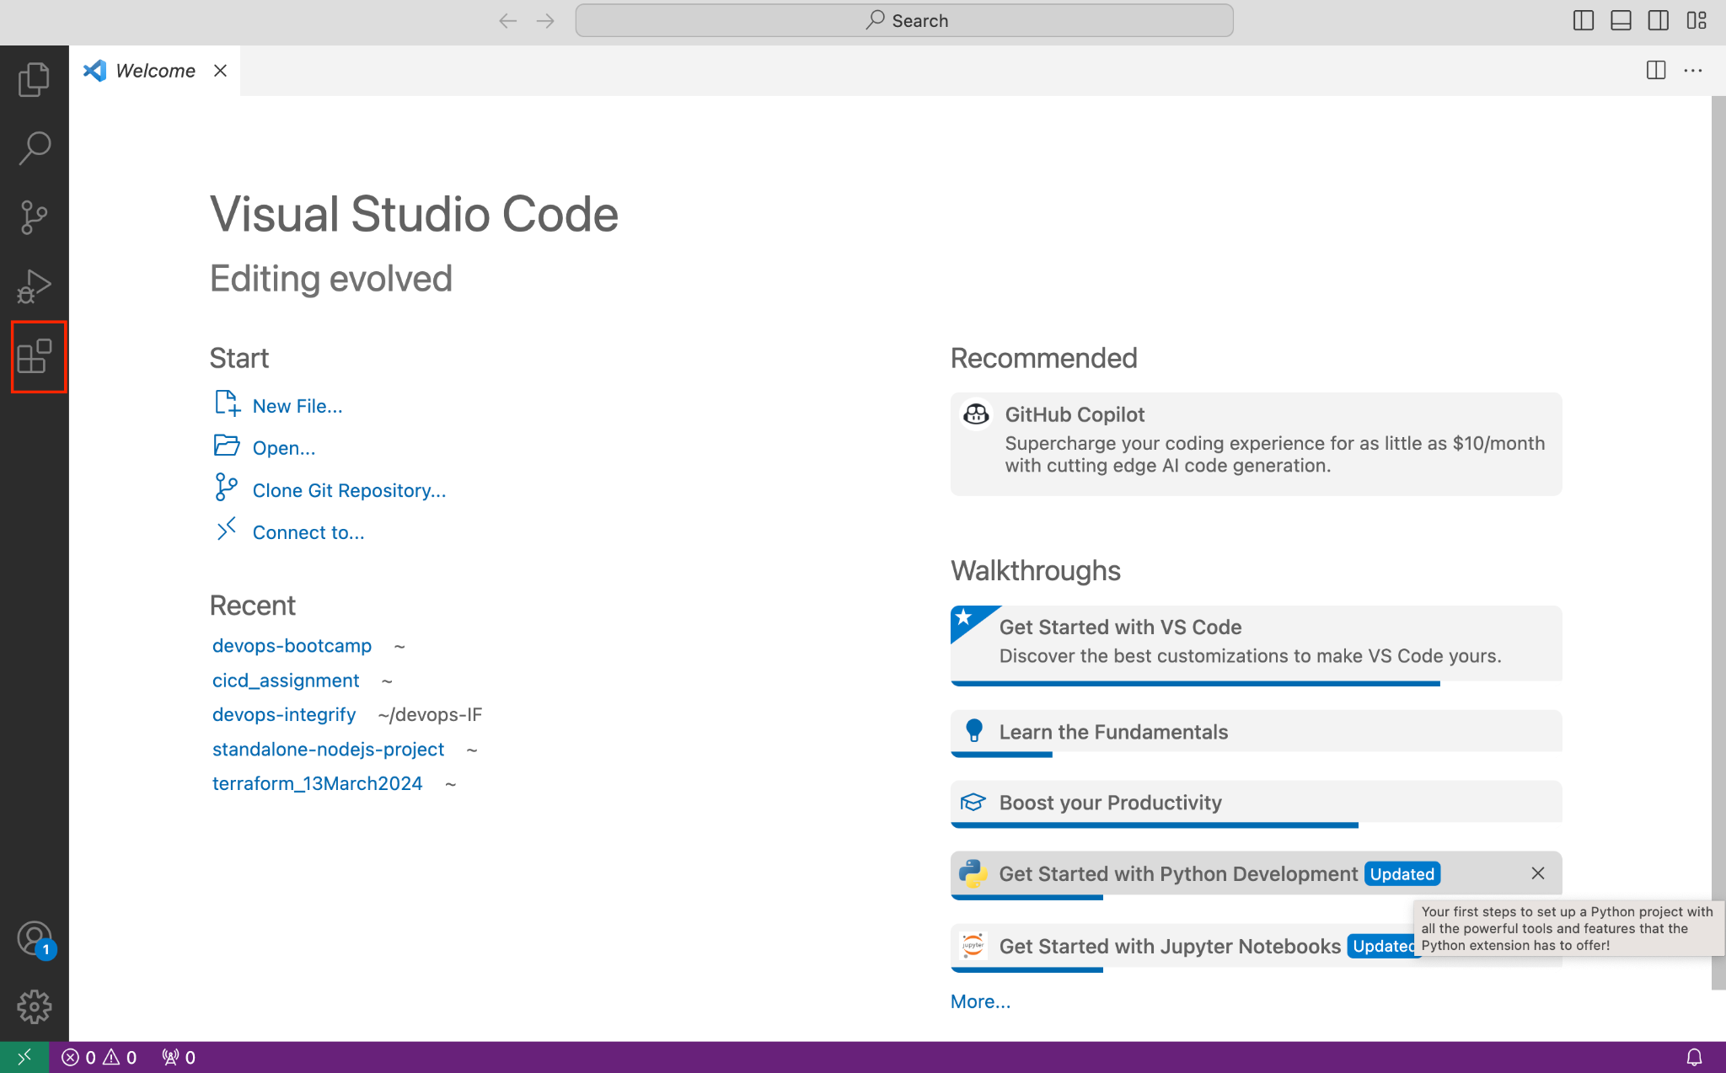

- Search for the terraform extension.

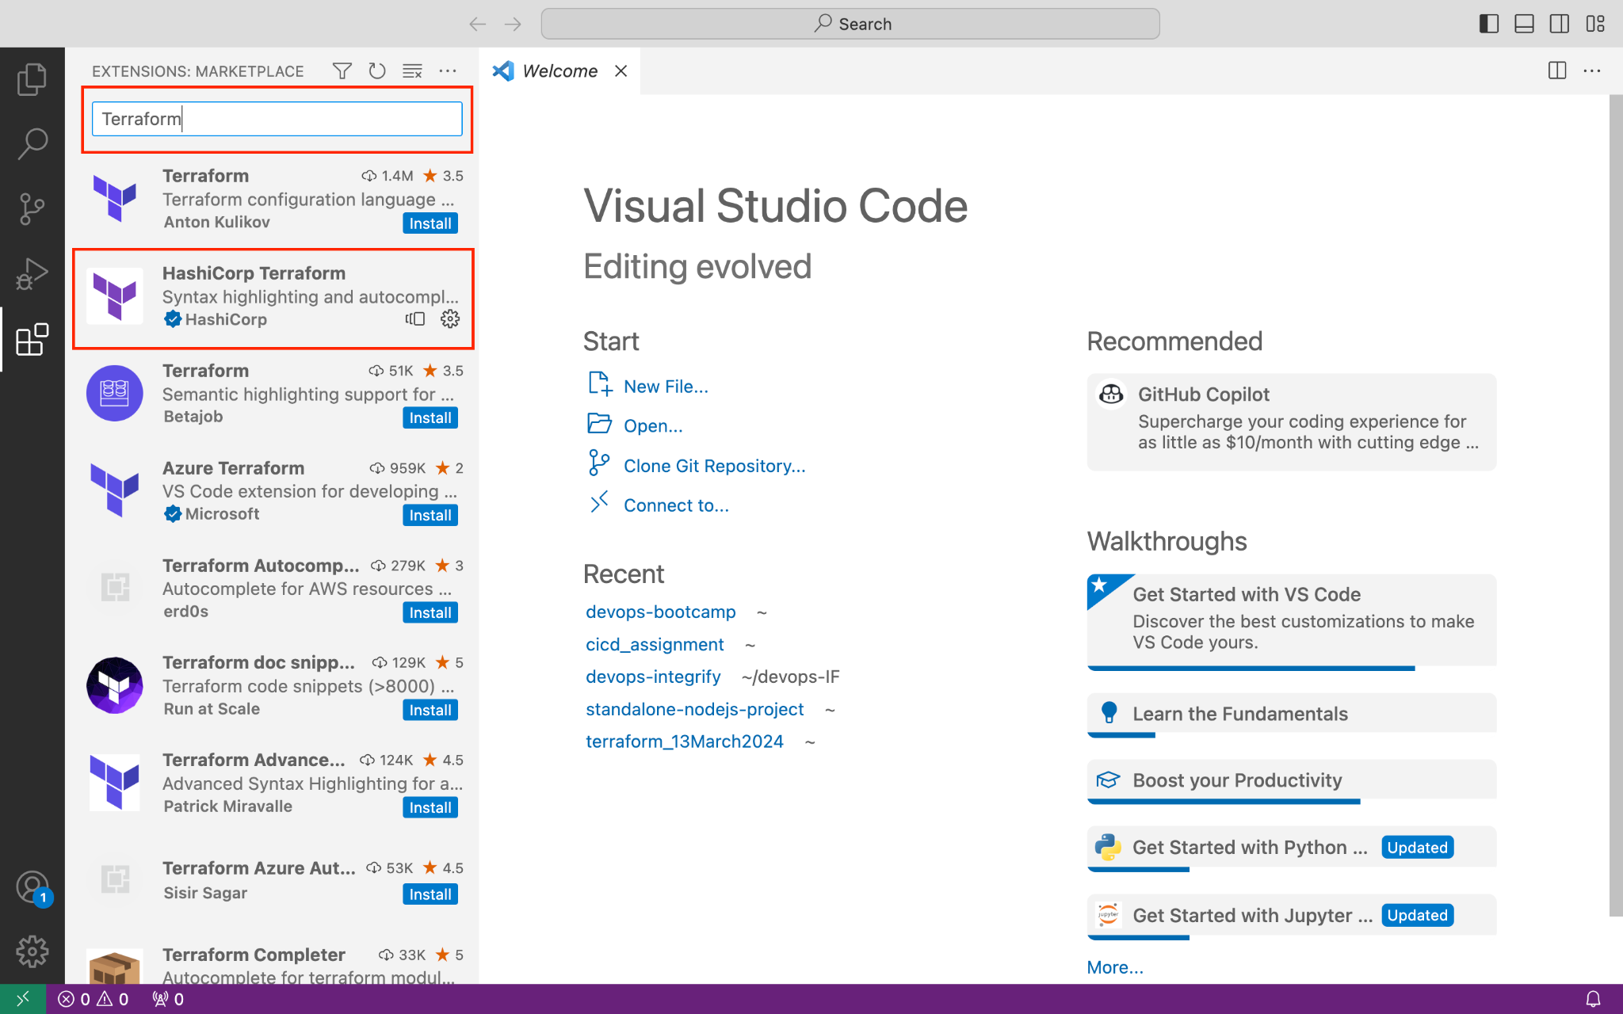

Install the extension.

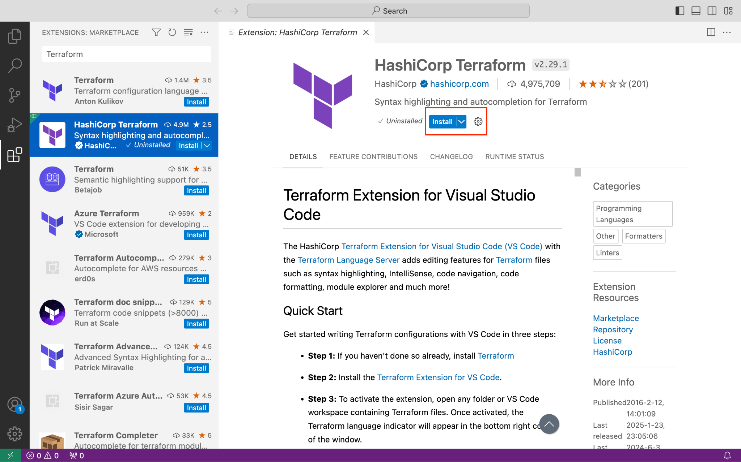

Setup is done and we are ready to write Terraform code.

